**ITAHARI NAMUNA COLLEGE**

**Faculty of Humanities and Social Sciences**

Itahari-10, Sunsari



**Lab report of Account**

**Submitted by :**

**Submitted to :**

**Name: Prasanga Pokharel**

**Name: Sushil Shah**

**Semester: 2nd Semester BCA**

**Table of Contents**

1. Introduction and about Tally
2. Create company
3. Create ledger group
4. Create ledger
5. Create ledger with related names
6. Create stock items with related names
7. Create related name godowns
8. Create Contra voucher
9. Create Purchase Voucher
10. Create Payment Voucher
11. Create Purchase Return voucher

12.Create Sales voucher

13.Create Receive voucher

14.Create Sales return

16.Create Stock transfer

18. Steps to view Reports on

* Day book
* Ledger Book
* Cash and bank book
* Godown
* Showing the transaction in to the trial balance
* Showing the transaction in to the profit and loss account
* Showing the transaction in to the balance sheet

**Introduction:**

Tally is an accounting program for recording and identifying accounting transactions. It aids in the organization of accounting transactions. Rather than storing accounting entries in bulky books that can be damaged, Tally makes the accounting process digital and more secure. Tally makes it easier to keep track of entries. All accounting operations, such as journals, ledgers, trial balances, and final accounts, can be accommodated. Similarly, it eliminates the need for time-consuming calculations because Tally can compute entered data, so all that is required is to enter the data.

**Features:**

Tally has the following features:

* Its innovative voucher entry method allows for a wide range of transactions.
* Users can have endless periods and budgets thanks to its auditing capabilities.
* Multiple ledgers, such as General, Sales, and Purchase, are combined into a single ledger.
* Because many companies involved in international trade perform transactions, it is progressively adjusting to encompass the use of numerous currencies.
* It allows the user to manage all receivable and payable billing information from top to bottom.

**Uses of Tally:**

Tally can be used everywhere that requires accounting. From little small stores to education institutes to huge corporations, it is used. It can be implemented in any company that conducts financial transactions.

**Interface:**

Tally ERP 9 is now open. The Company Info interface will appear. It includes the following features:

* Select Company.
* This tab allows you to create companies as well as select created companies.
* Login as Remote User.
* Create a company.
* This tab allows you to create as many companies as needed.
* Backup.
* Restore

**Getting started with tally**:

* Install Tally ERP 9 properly on your computer.
* Click on icon and open it.

**Creating a company in Tally. ERP 9:**

* Go to Gateway of Tally
* In Company info we can see Create Company.
* Select it, Company creation window will appear.
* At last, the message Accept? Yes/ No will Displayed.
* Press Enter or Y to save the details.

**Creating accounting Ledgers:**

* Go to gateway of tally
* Selects Account Info and Click on Create
* Enter name of account and fill other data.

**Voucher Entry:**

In accounting terms, a voucher is a document containing the details of a financial transaction. For example, a purchase invoice, a sales receipt, a petty cash docket, a bank interest statement and so on. For every such transaction made, a voucher is used to enter details into the ledger to update the financial position of the company.

**1. Creating a company**

Creating a company means creation of the new company with all the information of the company.

Objective : To create a company. Steps to create a company are listed below:

Step1: At first press alt+f1

Step2: click create company

Step3: Select the Directory, Enter name of company, Address, etc. like shown in below picture. And after filling all the information press enter to save it.

Step 4: remember to press enter and press yes after filling information

Step5: now your company is created

Step6: now you can start to record accounting transactions.

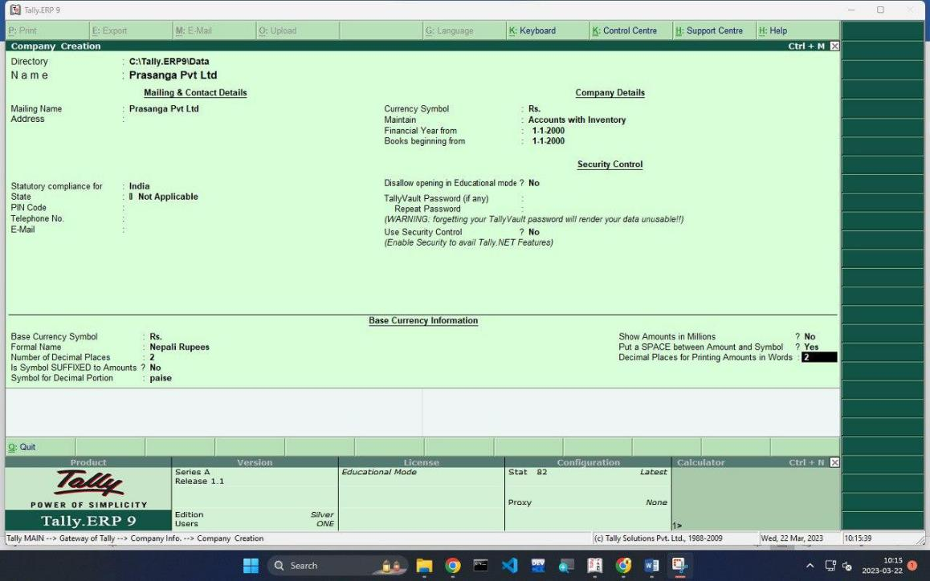

**2. ledger group.**

Objective : To create a ledger group named itahari debtors and itahari creditors

Step 1: Login to your Tally Software.

Step2: Navigate to the Ledger Group screen.

Step 3: Enter the name of the ledger group you wish to create.

Step 4: Select the type of ledger group you wish to create (asset, liability, income or expense).

Step 5: Set the opening balance and assign the ledger accounts to the group.

Step 6: Click “Save” to create the ledger group.

Step 7: Repeat the steps above to add more ledger groups.

Below here is the example of creation of ledger groups:

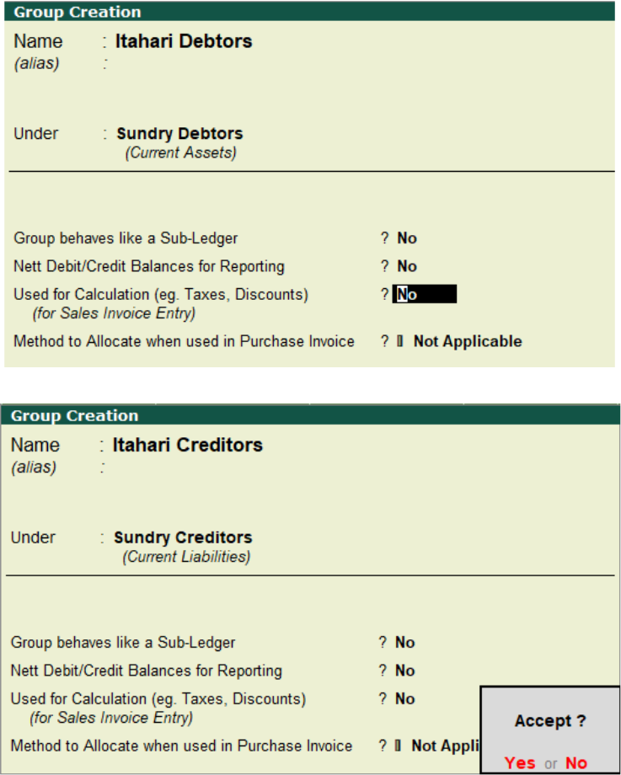

**3. ledger**

Objective **:** To create a ledger account of opening balance with cash in hand 100000 and Nabil bank 50000.

Step 1: Go to Gateway of Tally > Accounts Info. > Ledger > Create.

Step 2: Enter the Name of the Ledger and select the under field as the group under which this ledger is to be created.

Step 3: Select the appropriate Ledger Type.

Step 4: Enter the opening balance.

Step 4: Press Enter to save the ledger.

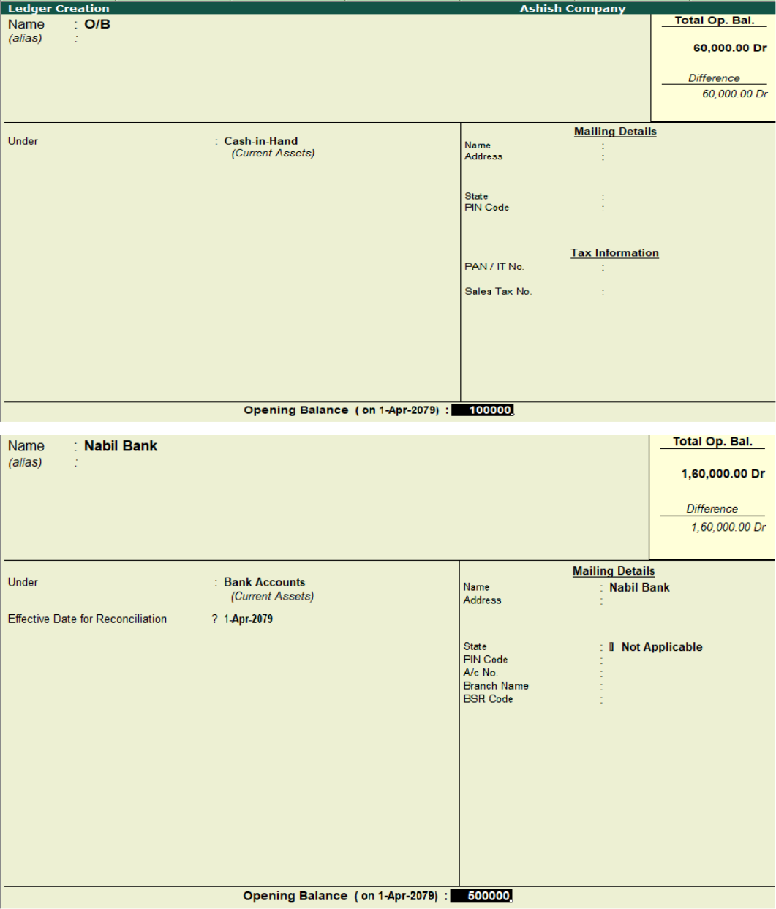

**4. Creation of Ledger:**

Ledger is the most essential for accounting in computerized accounting. Without a ledger we cannot create any vouchers. Therefore, ledger must be created under any group master as per defined or user defined.

**OBJECTIVE:** To create a ledger named hari Pvt.Ltd under Kathmandu debtors and sita Pvt.Ltd under Kathmandu creditors.

Step 1:Start Tally and open a Company.

Step 2: Go to Gateway of Tally > Accounts Info. > Ledger > Create.

Step 3: Enter the Name of the Ledger and select the under field as the group under which this ledger is to be created.

Step 4: Select the appropriate Ledger Type.

Step 5:Press Enter to save the ledger.

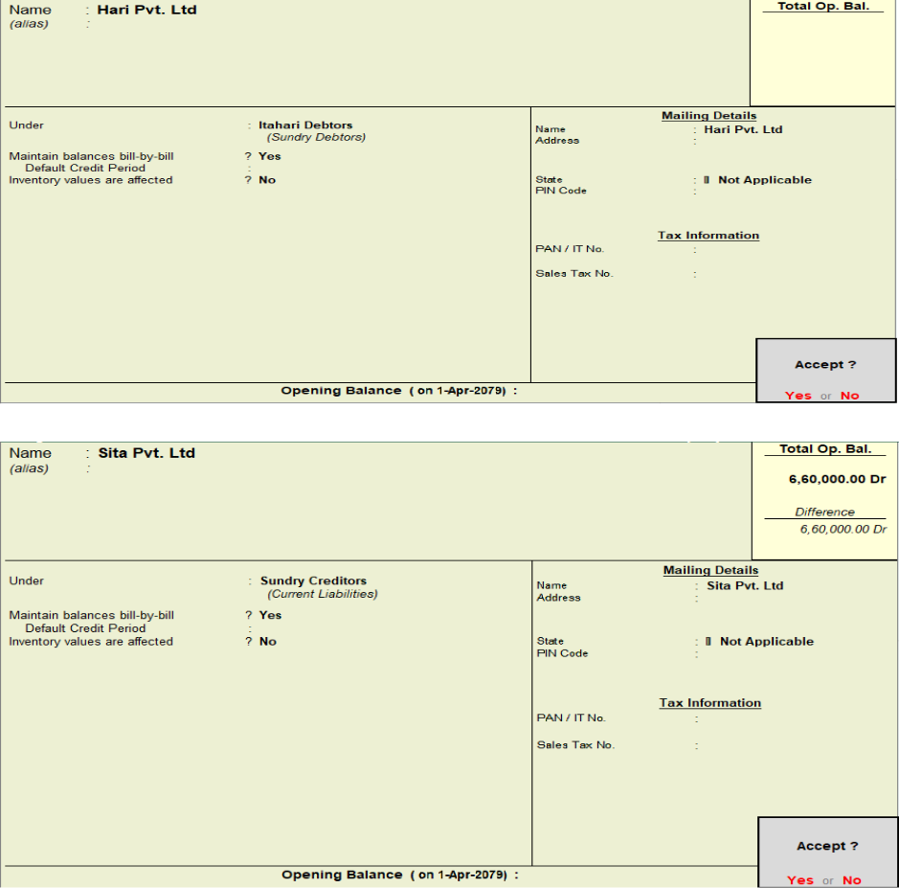

1. **Creation of Stock Group**

Objective: Creation of Stock Group named noodles with packet as unit and stock item named wai wai in tally. Steps are given below clearly:

Step 1: Open Tally ERP 9 and go to Gateway of Tally.

Step 2: Go to Features > Inventory Features > Stock Groups.

Step 3: Enter the name of the Stock Group and a brief description and set its nature.

Step 4: Enter the under field to specify the parent Stock Group.

Step 5: Press Enter to save the Stock Group.

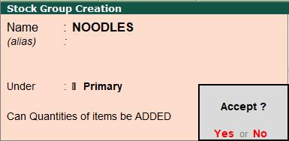

**Stock unit creation.**

Step 1: Go to the gateway of tally >Inventory info > unit of measure>create unit.

Step 2: Enter the symbol of the unit

Step 3: Symbol type be simple

Step 4: Type the desired symbol

Step 5: Press enter to save.

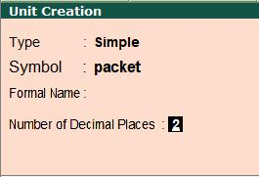

**Create stock item related name**

Step 1: Go to the gateway of tally >Inventory info > stock item>create.

Step 2: Enter the name of the stock item

Step 3: Select the group and units.

Step 4: Enter the opening quantity and rate per unit.

Step 5: Press enter to save.

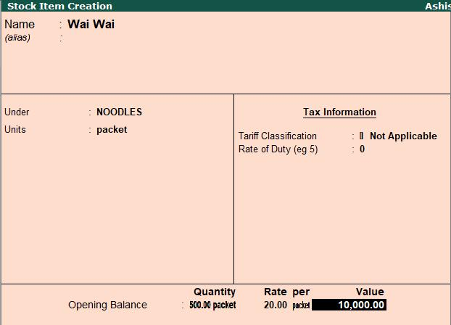

1. **Creation of Godown:**

Objective: To create a Godown named sunsari and Biratnagar under primary**.**

Steps are given below respectively:

Step 1: First you move to enable multiple godown option by pressing F11 and then press F2 you will get the option.

Step 2: - Click on Inventory info. Option under Masters heading.

Step 3: - Then click on GoDowns option.

Step 4: - Click on create option under single godown heading.

Step 5**: -** Fill up the information like shown in the figure below: -

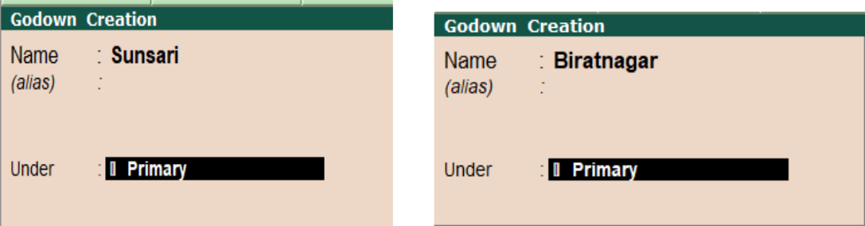

**7. Contra Voucher**

A Contra Entry is an entry in a business book of accounts, indicating transfer of funds from:

* Cash account to bank account
* Bank account to cash account
* One bank account to another bank account

To open Contra Voucher: -

Step 1: Click on Accounting Voucher

Step 2: After That Press F4 to go to Contra Voucher Page

Question: Company Transfer Amount Nabil Bank to Siddhartha Banks Rs 15000.

Steps to create Contra voucher:

Step 1: - Go to Gateway of tally and under the heading Transaction click on Accounting Vouchers.

Step 2: - Press F4 to create voucher of contra.

Step 3: - Enter the journal of contra entry as shown in the figure below:

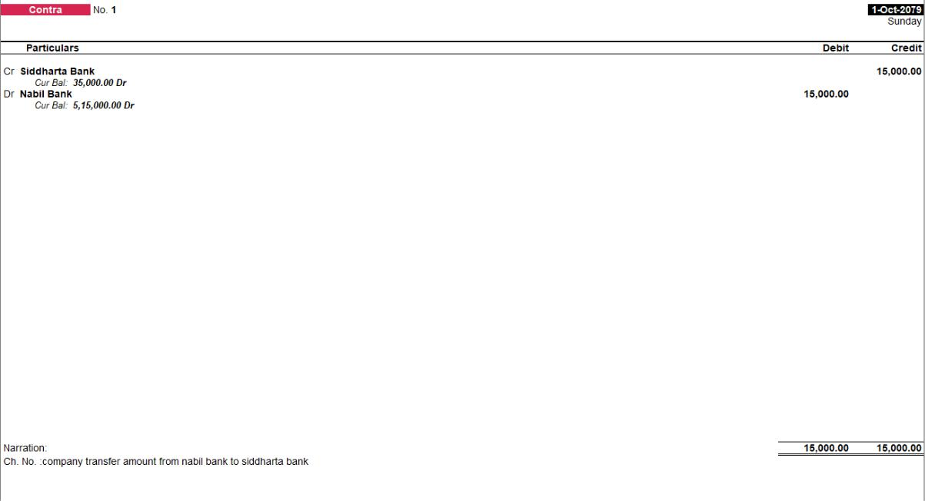

**8. Purchase Voucher**

All the cash purchase or purchase from suppliers on credit in this case purchase voucher is used (Base on invoice format)

Steps: -

Step 1: - Go to Gateway of tally and under the heading Transaction click on Accounting Vouchers

Step 2: - Press F9 to create purchase voucher.

Step 3: - Enter the party name

Step 4: Enter the purchase ledger. By clicking alt+c.

Step 5: Enter the items name

Step 6: Enter the qty. rate. Amount

Step 7 : Finally save it

Question: A Company Purchase wai wai from hari pvt. Ltd of Quantity 550 at the rate of RS.20.

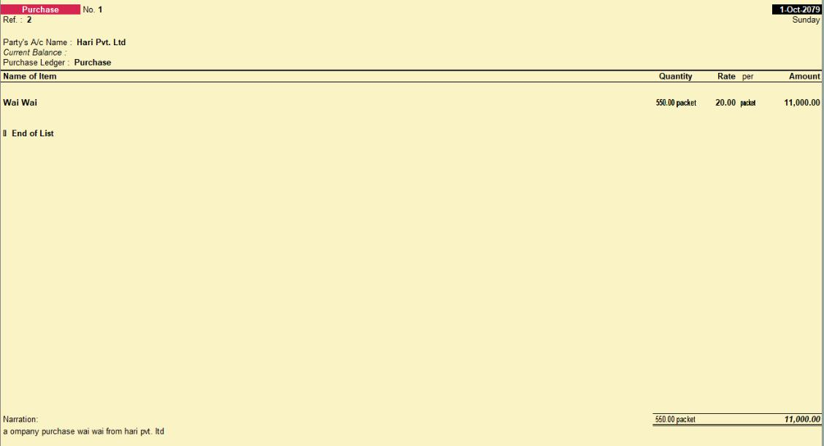

Steps To view report of purchase are shown below:

Step 1: Display

Step 2: Account book

Step3: Purchase register

Step 4: Define the month

Step 5: Then you can see the report

**9. Payment Voucher:**

A payment voucher is a way to record payments made to suppliers and maintain a history of payments that your business has made.

Objective: To create payment voucher where a company pays cash to hari Pvt Ltd for purchase of goods.

Steps to open Payment Voucher are given below:

Step 1: - Go to Gateway of tally.

Step 2: Click on Accounting Voucher

Step 3: After That Press F5 to go to Purchase Page

Step 4: Enter the receiver ledger and enter the amount

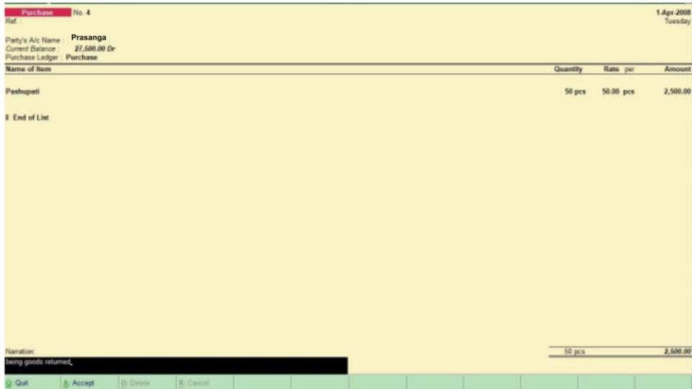

1. **Purchase Return voucher**

To use Purchase Return Feature, you have to enable following things by pressing F11 key.

Use Debit and Credit Notes - YES

Record credit notes in invoice mode - YES

Record debit notes in invoice mode – YES

Steps to create purchase return voucher.

Step 1: Gateway of tally > voucher > press f10 > type or select debit note and press enter.

Step 2: Press ctrl+H to select the required voucher mode.

1. Party A/C name.
2. Party detail.

Step 3: Select the purchase ledger to allocate the stock items

Step 4: Provide the stock items details

1. Select the stock item
2. Enter the quantity, rate will be automatically filled, based on rate , entered on the previous transaction.

Step 5: Accept the screen.

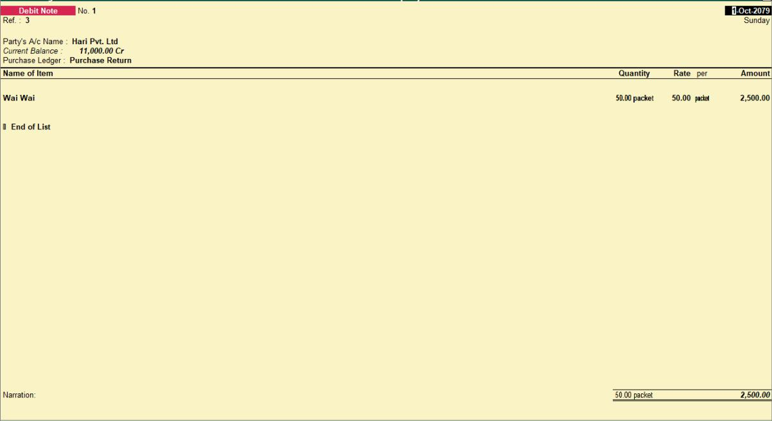

**11. Sales Voucher**

Objective 11: To create a sales voucher where company sales goods to Ashish

Theory: A sales voucher is used when a company sells goods to its customer whether on cash or credit. Steps to create sales voucher.

Step 1: - Go to gateway of tally > Accounting voucher > F8 sales.

Step 2: - Change the date if needed by pressing F2 or date button.

Step 3: - Click on account invoice button if no stock is involved in the sales, or click on item invoice if stock items are needed to be selected.

Step 4: - Enter ref no. party A/C name, particulars, rate and amount in case you have choosen amount invoice.

Step 5: - Enter ref no. party name, sales ledger, name of item, quantity and rate in case you have choosen item invoice.

Step 6: Write the narration and save it.

Question: A company sales wai wai to Ashish Quantity 100 pcs, Rate 70.

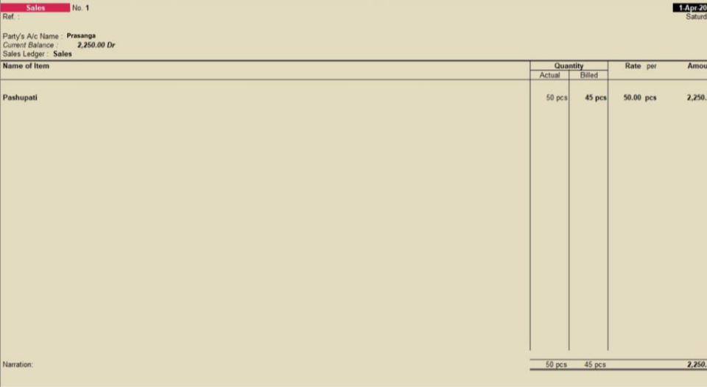

1. **Receive voucher:**

Theory:

A receipt voucher is used when a company receives cash or cheque for the sale of goods on credit or for other purposes. Eg: Income earned, received money from sales.

Objective 12: To create a receipt voucher where company receives cash for sale of goods.

Step 1: - Go to gateway of tally > Accounting voucher creation

Step 2: - Click on receipt button or f6.

Step 3: - Choose the relevant Bank a/c name in which money is received.

Step 4: - Choose the customer name from which money is being received.

Step 5: - Under the costumer specify the received amount.

Step 6: - Specify a narration under narration field.

Step 7: **-** Following figure is an example of receive voucher.

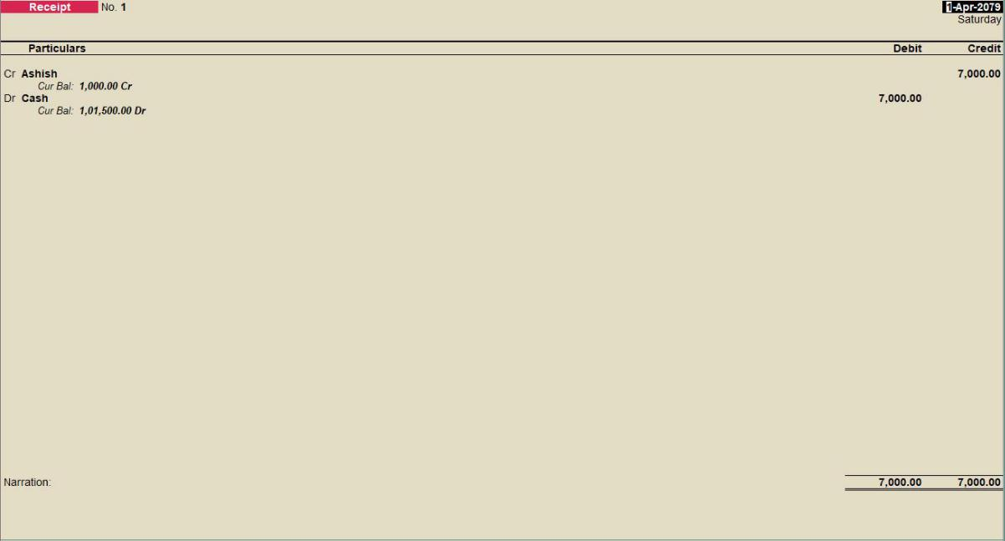

1. **Sale return voucher:**

Theory:

A sales return voucher is used when a company receives the good back from the customer whether the good was sold on cash or credit.

Objective: To create a sales return voucher where a company receives back the sold goods. Steps are shown below:

Step 1: - Enable the credit note feature by pressing f11 and select option use debit and credit note to yes.

Step 2: - Open the credit note voucher.

Step 3: - Specify the buyer details.

Step 4: - Select the sales ledger to allocate the stock items, provide stock item details.

Step 5: - Select the bill wise detail.

Step 6: - Provide the narration if needed.

Step 7: - Accept the screen.

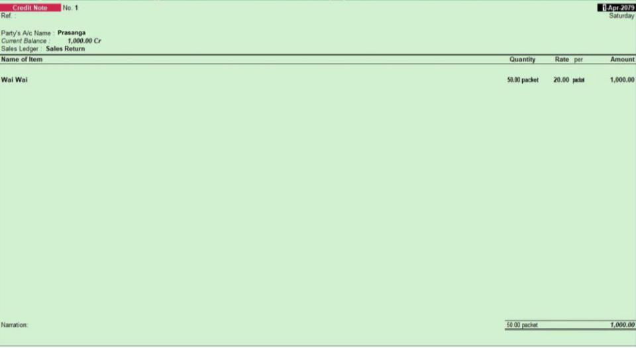

1. **Additional cost voucher:**

Objective 14: To create a purchase voucher where there is additional charge on purchase.

Theory: When there exists additional cost on purchase like labor charge, delivery fee, etc, a purchase voucher is used in its voucher form.

Step 1: Press f11 > Inventory features > Track additional cost on purchase > yes.

Step 2: After activating the feature create related ledger.

Step 3: Entry should be passed in the purchase voucher (f3). During entry you have to see an additional window on which you set all your direct expenses. It increases cost of your production.

Note: After passout the entry if you see the p and l a/c there is no amount display in expenses a/c because it will adjust in purchase a/c.

Step 4: Accept the screen.

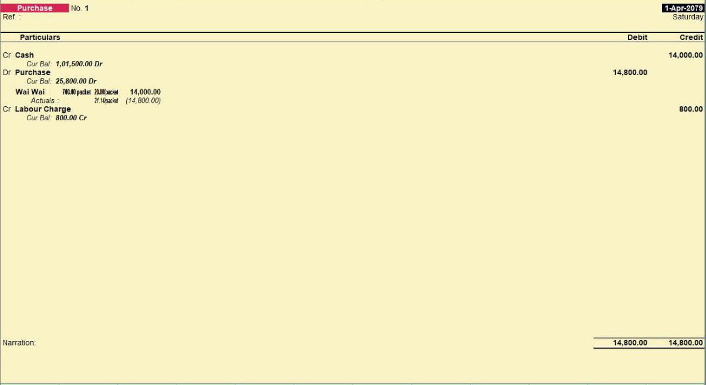

1. **Stock Transfer:**

Theory: A stock journal voucher is used when a company transfer its goods from one godown to other.

Objective 15: To create a stock journal where a company transfers stock from Itahari godown to Dharan godown.

Step 1: - First we create a manufacturing journal voucher.

Step 2: - Go to gateway of tally > Inventory voucher

Step 3: - Press the button ALT + f7

Step 4: - Now enter the following details.

a)Date b) Ref no

Step 5: - For source (consumption):

Enter the name of item, godown, quantity rate and amount also for destination.

Enter name of item godown quantity rate and amount.

Note : to get additional cost details in the stock journal voucher enable track addition

cost of purchase in f11: features.

Step 6: - Accept the screen.

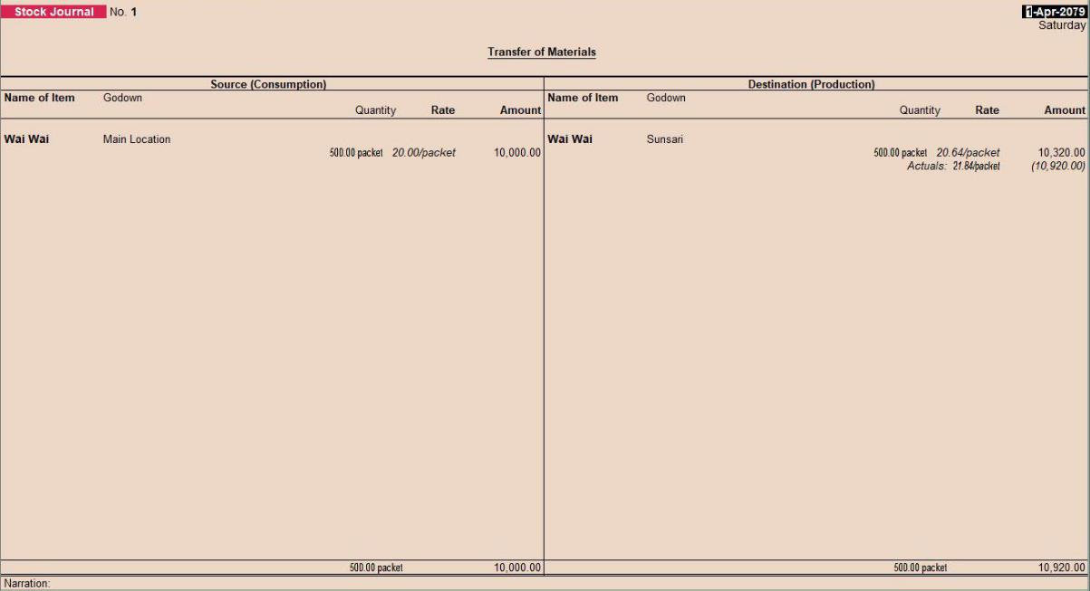

**16. Voucher Type.**

Objective: To create a sales voucher type which automatically includes 13% vat.

Theory: A sales voucher type is created for special purposes when there should be automatic vat, tax or discount. Steps are shown below:

Step 1: - Go to gateway of tally press f11 and enter on statutory and taxation, and activate the value added tax feature.

Step 2: - Then go to the sales voucher, change date if needed by pressing f2 or date button.

Step 3: - Enter ref no, party a/c name, and other details present their.

Step 4: - Enter the name of item to be sold, its quantity rate and all, after entering all the items press enter key and create the ledger of vat and enter the percent of vat which should be added in total.

Step 5: - Write the narration and save the voucher by pressing enter key.

**17. Actual bill quality:**

Theory: Such sales voucher is used when there are specific offers like buy one get one free.

Objective: To create sales voucher for actual and billed quantities. Steps are shown below:

Step 1: Press F11 and go to inventory features.

Step 2: Enable the use separate column for actual and billed quantity option.

Step 3: Open sales voucher from accounting vouchers.

Step 4: Enter the party’s name and goods detail.

Step 5: Enter total goods in actual and free goods in billed quantity.

1. **Step to view report:**

1. Day book

Step 1: On gateway of tally

Step 2: Go to display.

Step 3 : Select day book.

2. Ledger book

Step 1: On gateway of tally

Step 2: Go to display.

Step 3: Select Account book

Step 4 : now click on ledger.

3. Cash and Bank book

Step 1: On gateway of tally

Step 2: Go to display.

Step 3 : Select Account book

Step 4: Now click on ledger.

Step 5 : Select cash or book.

4. Godown

Step 1: On gateway of tally

Step 2: Go to display

Step 3 : select statement of inventory.

Step 4: Click on godown.

5. Showing the transaction in trial balance

Step 1: On Gateway of tally

Step 2: On display menu select Trial balance

Step 3: You can see all the transaction in the trial balance

6. Showing the transaction into the profit and loss account

Step 1: On Gateway of tally, go to Profit and loss A/c under Reports section to see the

Step 2: profit and loss account on the transaction.

7. Showing the transaction into the balance sheet

Step 1: On Gateway of tally, go to Balance sheet under Reports section to see the

Step 2: profit and loss account on the transaction.